**WIREFRAME AND INITIAL PLAN**

|  |  |  |  |
| --- | --- | --- | --- |
|  |  |  |  |
|  | Machine generated alternative text: BANNER  IMAGE (DEPENDENT ON WEBPAGE)  FACT 1/2  MAIN/NAV  LOGO  FACT 5/6  FACT 3/4  FOOTER  Machine generated alternative text: Proportional palette  Hex color  a2133  #af5621  #683533  #3321 13  #014669  #2165a7  #0fcbfd  #fcbbl 5  #773400  Area  18.8 %  10.0%  9.5 %  8.2 %  8.1 %  Closest color name  Midnight Express (Blue)  Christine (Brown)  Persian Plum (Brown)  Bistre (Brown)  Bahama Blue (Blue)  Mariner (Blue)  Summer Sky (Blue)  Selective Yellow (Yellow)  Saddle Brown (Brown)  Mango Tango (Orange) |  |  |
|  |  | Machine generated alternative text: Proportional palette  Hex color  a2133  #af5621  #683533  #3321 13  #014669  #2165a7  #0fcbfd  #fcbbl 5  #773400  Area  18.8 %  10.0%  9.5 %  8.2 %  8.1 %  Closest color name  Midnight Express (Blue)  Christine (Brown)  Persian Plum (Brown)  Bistre (Brown)  Bahama Blue (Blue)  Mariner (Blue)  Summer Sky (Blue)  Selective Yellow (Yellow)  Saddle Brown (Brown)  Mango Tango (Orange) |
|  |  |  |

Please note that this is not the final version of the wireframe. In the final version, the ‘image’ section has been replaced with the ‘navigation’ section for easy access to other pages.

**IMPLICATIONS**

**AESTHETICS**

My website must look good and function properly, otherwise people might not visit it or use it. To solve this, I will base my colour scheme on my logo picture and have a pre-determined colour palette. I will also ensure I do not deviate far from my original wireframe. This will make my website look good and function as intended.

**HOW I ADDRESSED THIS:**

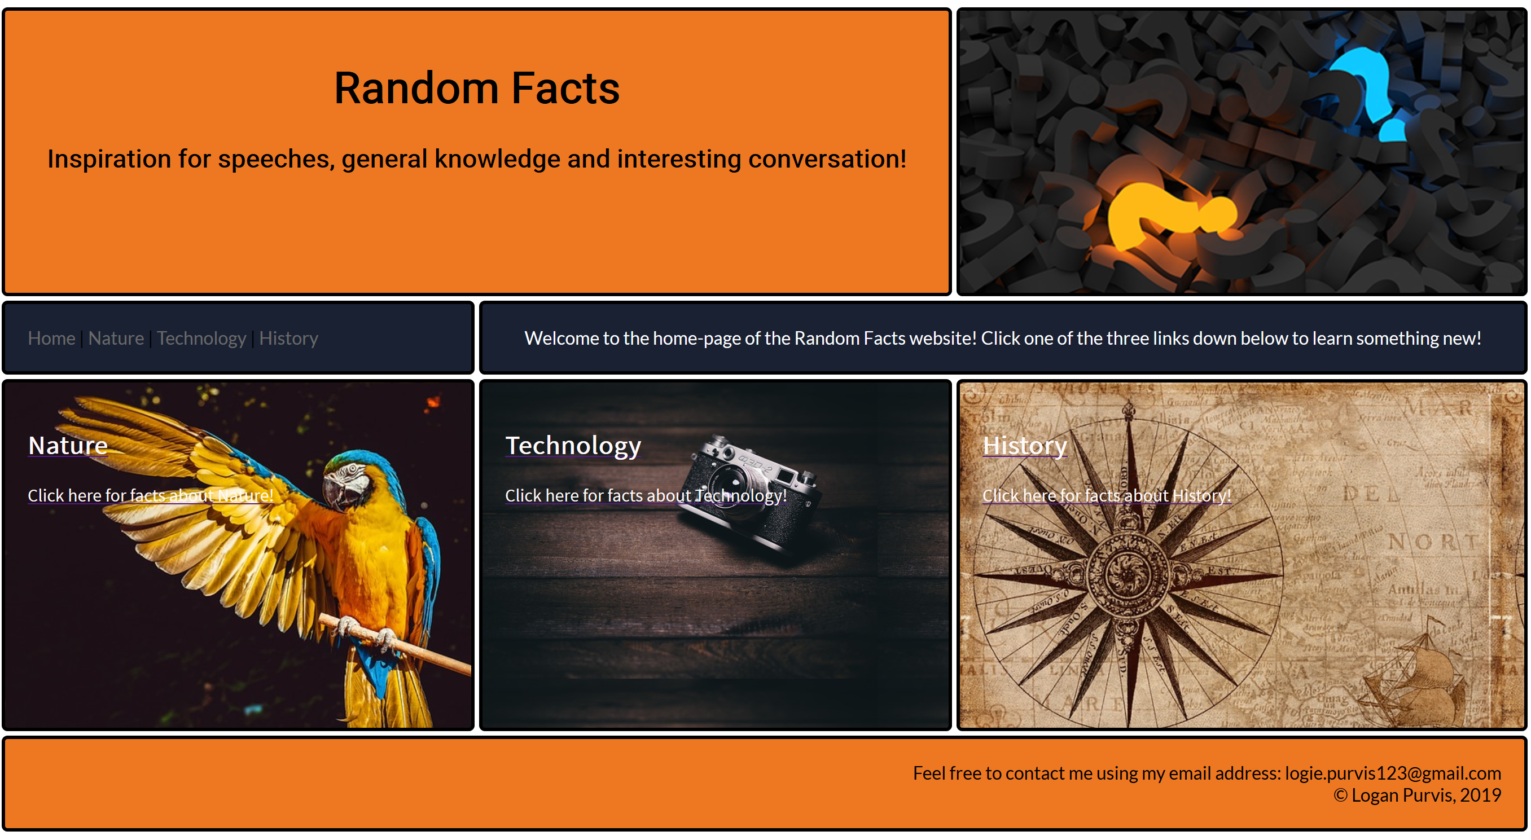

My website not only looks good, but functions as intended. The user can click on one of the photos to be sent to the fact page, or click the links up on the top-left corner.

**END-USER CONSIDERATIONS**

My website has a target audience. This must be considered, and my website must be adapted to meet the requirements of said audience. Since my target audience is broad, the website has to be easily accessible and functional. Links and text need to be readable and clear to the audience and pictures must not make the text unreadable. The website also needs to be socially and culturally acceptable. This means I cannot use discriminatory language or images targeted to any culture.

**HOW I ADDRESSED THIS:** 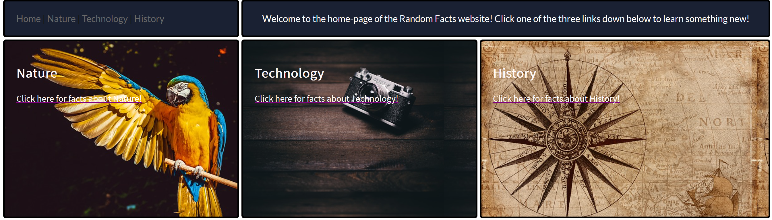

My website is tailored towards my end users. I have considered my end-users to be anyone who is interested in unique speech topics or learning something new. Because of this, my website had to be intuitive and easy to navigate. For this reason I have turned three panels on the Index page into a link with an explanation on how to get to a certain page. This not only looks good, but helps the end-users navigate my site. There is a navigation bar in case the end-user wishes to quickly navigate to a certain page and a written explanation on how to get to these sites on the ‘main’ panel (the one above ‘Technology’ and ‘History’.)

I have taken great steps to ensure cultural appropriation in my website. No offensive or discriminatory images or text has been used.

**COPYRIGHT/LEGAL**

Copyright is a great issue for anyone who needs to use a picture in a website or other digital media application. For this assessment I must use non-copyrighted material and ensure I honour property obligations.

**HOW I ADDRESSED THIS:**

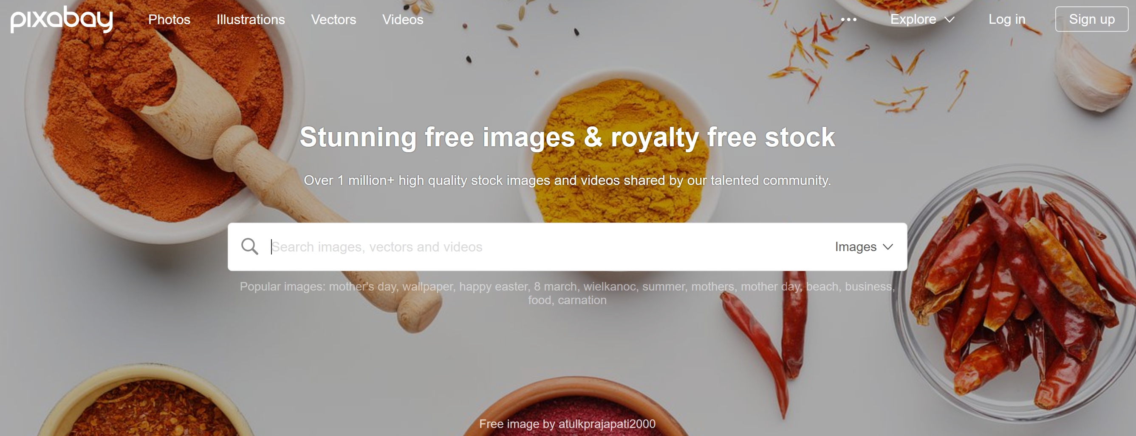

I have used [Pixabay](https://www.pixabay.com) for my images exclusively. This is a stock website that helped me avoid copyright implications, hence honouring property obligations.